**PSP**

**Assessed exercises**

You will write code that manipulates a film database stored in a text file “films.txt”. For each film, we will store the **name** of the film, its **director** and two main **actors** that were in the film. The information will be stored on one line with the components separated by commas. For example one line of the file could be:

*The Shawshank Redemption,Frank Darabont,Tim Robbins,Morgan Freeman*

**The information about a list will be stored as a list where the first item is the title, the second the director and the res the actors:**

***[“Terminator”, “James Cameron”, “Arnold Schwarzenegger”, “Linda Hamilton”, “Michael Biehn”]***

**And the database as a whole will be a list of lists.**

**The content in the file “films.txt” as following:**

*The Shawshank Redemption,Frank Darabont,Tim Robbins,Morgan Freeman*

*The Godfather,Francis Ford Coppola, Marlon Brando,Al Pacino*

*The Dark Knight,Christopher Nolan,Christian Bale,Heath Ledger*

**Write and test functions to do the following. Each function below is followed by code indicating how the function would be called** (You cannot change the name and parameter of the functions).

a) load the films into a database from the file (**films.txt**) and return it

films = loadFilms()

b) list all the films in the database

printFilms(films)

c) add a film to the database

films = addFilm(films)

d) save the films in a database to file (**newfilms.txt**)

saveFilms(films)

Your program should follow the test case with same input and output.

（See next page）

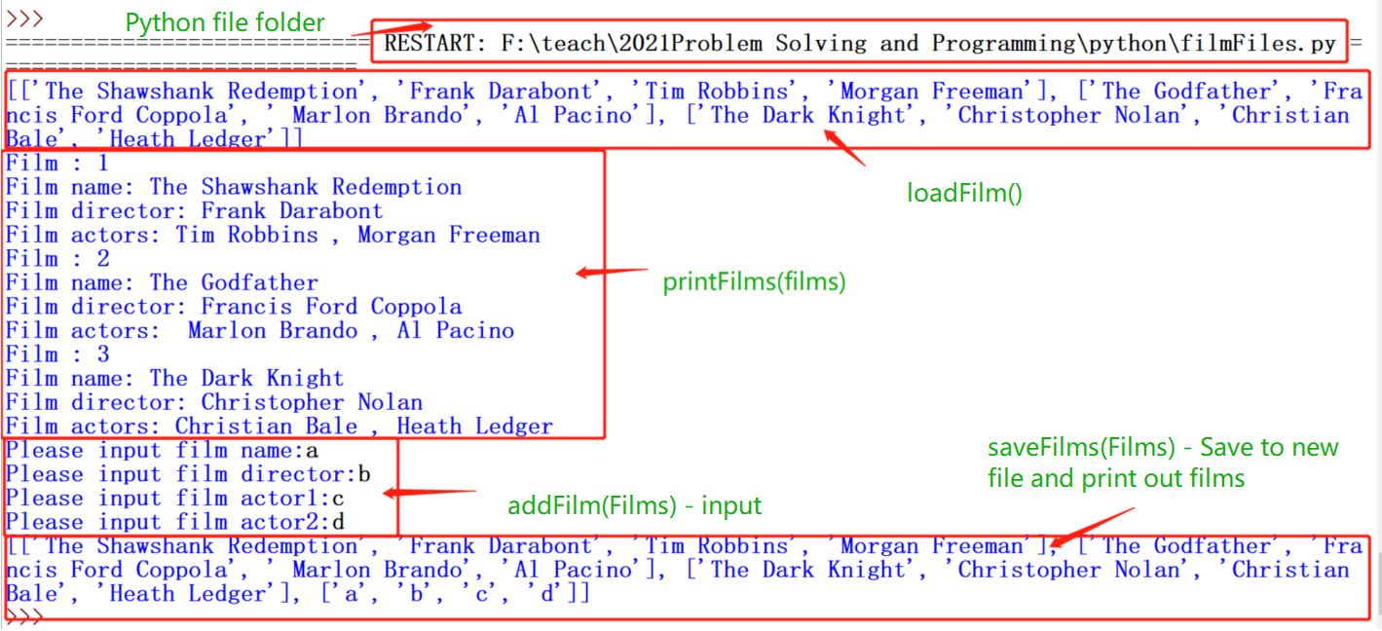

The content in newfilms.txt as following text:

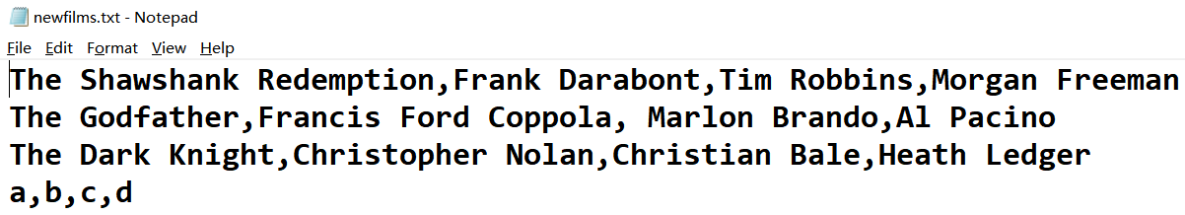

Complete the implementation and testing. Your program should have necessary comments for loop and selection, and also should write documentation strings for every function.

1. Implementation

**(Paste your own program with screenshot)**

1. Testing

**(1. Paste the example test plan with screenshot of same input and output first;**

**2. Paste your own test plan with screenshot; )**